Review Part 2

Multiple-Choice Questions

1. In the reaction shown below, all gases are measured at SATP. What volume of nitrogen, N₂(g), reacts with 1.120 L of hydrogen, H₂(g), to form ammonia, NH₃(g)?

3H₂(g) + N₂(g) → 2NH₃(g)

- 0.373 L
- 1.120 L
- 2.240 L
- 3.360 L

2. A sample of methane gas has a volume of 5.881 L at STP. The temperature decreases by
23.00 ºC and the pressure rises by 5.700 kPa. Which expression can be solved to find the correct new volume?

- 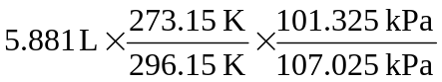

- 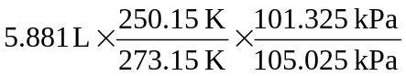

- 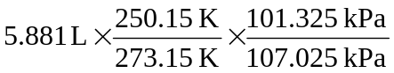

- 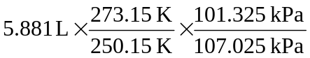

3. A container holds a 4.00 L sample of propane gas. If the pressure on the gas in the container is increased by a factor of 4 and the Kelvin temperature is doubled, what is the new volume?
- 1.00 L
- 2.00 L
- 8.00 L
- 32.00 L

4. The partial pressure of gas A in a sample is twice the partial pressure of gas B in that same sample. The number of particles of gas A is ________ the number of particles of gas B.
  - twice
  - half
  - the same as
  - less than

5. 3.50 mol of oxygen gas is added to an empty, deflated balloon at 90.0 ºC and standard pressure. To what volume will the balloon expand?
    - 8.12 L
    - 104 L
    - 8.51 L
    - 126 L

6. A sample of gas is trapped at standard temperature and pressure. The gas has a mass of 0.301 g and a volume of 0.153 L. What is the identity of this gas?
      - CH₄
      - NH₃
      - C₂H₆
      - CO₂

7. Students performing a chemistry experiment reacted nitrogen gas and oxygen gas. They found that 20 mL of nitrogen gas reacted with 40 mL of oxygen gas to produce 40 mL of nitrogen dioxide gas. In order to produce 1.0 L of nitrogen dioxide gas, they would need to use _____ L of nitrogen gas.
- 1.0
- 2.0
- 0.50
- 0.25

8. What volume will 36.0 g of water occupy when it evaporates to water vapour at SATP?
- 24.8 L
- 99.2 L
- 49.6 L
- 44.8 L

9. The molar volume of all gases is the same at STP, yet equal volumes of different gases at STP have different densities. This is because
- there are different numbers of particles of each gas
- the pressures are different for each of the gases
- the particles of each gas have different average speeds
- the particles of each gas have different masses

10. The molar volume of hydrogen gas at 50.0 kPa and 300 K is
- 22.4 L
- 24.8 L
- 45.1 L
- 49.9 L

12. For a mixture of gases in a closed container to behave ideally, each gas exerts the same pressure as if it alone occupied the entire container. This is a statement of
- Charles’s law
- Dalton’s law of partial pressures
- Avogadro’s law
- law of combining volumes

13. A sample of gas in a closed container contains 1.00  10²¹ molecules. The volume of the container is decreased and the temperature is increased. Assuming ideal behavior is maintained, which statement about this sample of gas is incorrect?
- The same number of moles of gas are present.
- The pressure in the container increases.
- The collisions between molecules are no longer elastic.
- The molecules are colliding more often.

14. Three gases are in a closed container at 25.0 ºC and 102.0 kPa pressure. The volume of the container is 5.00 L. In this mixture, 25% of the molecules are gas A, 55% are molecules of gas B, and the remainder are molecules of gas C. What volume is occupied by the molecules of gas C?
- 5.00 L
- 4.00 L
- 1.25 L
- 1.00 L

15. If you had 2.0 g of each of the following gases at STP, which would have the greatest volume?
- NH₃
- N₂
- NO
- N₂O

16. What volume of N₂(g) contains the same number of molecules as a 4.04 g sample of H₂(g) if each gas is measured at STP?
- 24.8 L
- 22.4 L
- 11.2 L
- 44.8 L

17. At SATP, 4.0 × 10²⁰ molecules of gas occupy 10.0 L. At these same conditions, a 20.0 L sample of this gas contains 8.0 × 10²⁰ molecules. This is an application of
- Charles’s law
- the ideal gas equation
- Avogadro’s law
- Dalton’s law

18. A sample of ideal gas cooled from 200 ºC to 100 ºC. By what factor must the pressure change if the volume is to remain constant?
- 100
200

- 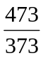

- 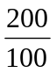

- 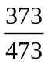

19. Under ideal conditions, the molar volume of He gas at STP is 22.4 L/mol and the molar volume of Ne gas at SATP is 24.8 L/mol. Which one of the following statements is correct?
- The number of molecules in both volumes is 6.02 × 10²³.
- There are more molecules in the 24.8 L of Ne than in the 22.4 L of He.
- The mass of the He sample is greater than the mass of the Ne sample.
- The number of molecules cannot be compared for two different gases.

Numerical Response Questions
For each numerical response question, record the answer in the following response box.
20. | 21. | 22. | 23.

20. A sample of gas is trapped at 25.0 ºC and 104.2 kPa pressure. The gas has a mass of 0.755 g and a volume of 0.253 L. What is the molar mass of the gas?

21. 14.67 mL of nitrogen, N₂(g) at 64.85 ºC and 40.675 kPa is cooled and the pressure drops by
10.00 kPa. The volume is now 10.46 mL. To what temperature, in degrees Celsius, was the sample cooled?

22. What is the mass of helium, He(g), in a balloon having a volume of 5.00 kL at −50.00 ºC and 68.3 kPa pressure?

23. The boiling point of liquid nitrogen is −195.79 ºC. At this temperature, the density of liquid nitrogen is 0.807 g/mL. 1.00 mL of liquid nitrogen is placed into a deflated balloon. What will be the volume of nitrogen gas in the balloon at STP?

Written Response Questions
Answer each question in the space provided. Use complete sentences and diagrams when necessary.

24. The kinetic energy of molecules in a sample of gas is given by the equation E_{k} = mv². The graph shown below represents the distribution of the speeds of molecules of helium gas, He(g), and nitrogen gas, N₂(g), at 50.0 ºC.
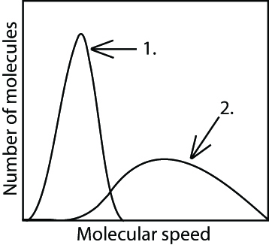

Which curve, 1 or 2, represents nitrogen gas molecules? Give a reason for your answer.
______________________________________________________________________________

______________________________________________________________________________

______________________________________________________________________________

______________________________________________________________________________

______________________________________________________________________________


26. A sample of an ideal gas is in a cylinder that is fitted with a movable piston.

List three ways in which the pressure can be increased inside this cylinder.

______________________________________________________________________________

______________________________________________________________________________

______________________________________________________________________________

Answers to Multiple-Choice Questions

1. a
2. c
3. b
4. a
5. b
6. d
7. c
8. c
9. d
10. d
12. b
13. c
14. a
15. a
16. d
17. c
18. b
19. a

Answers to Numerical Response Questions

20. 71.0 g/mol | 21. −91.40 ºC | 22. 736 g | 23. 0.646 L

Answers to Written Response Questions

24. Nitrogen molecules have a larger mass than helium molecules. If both are at the same temperature, they have the same average kinetic energy. But to keep the kinetic energies the same, the molecules with a larger mass move more slowly. Curve 2 represents the nitrogen molecules.

25. Three ways to increase the pressure inside the cylinder are: decrease the volume by pushing down on the piston; increase the temperature at constant volume; add more of the gas at constant temperature and volume.

