Bonding Unit Review – Part 2

Multiple-Choice Questions

2. In an ionic lattice, the structure is made up of a repeating pattern of
- atoms all linked by covalent bonds
- formula units in a geometric arrangement of unit cells
- positive ions in a sea of electrons
- positive ends of one molecule attracted to the negative end of another

Use the structures below to answer questions 3 and 4.

(i) (ii) (iii) (iv)
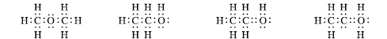

3. Each of the Lewis structures above has the molecular formula C₂H₆O. Which Lewis structures are correct?
- (i) and (iii) only
- (i), (ii), and (iii) only
- (i) and (ii) only
- All are possible correct structural formulas.

4. Which one of the following statements is correct about Lewis structure (i)?
- The molecule is bent and is a dipole.
- The molecule is linear and is a dipole.
- Hydrogen bonding can occur between molecules.
- There is a double bond to the oxygen atom.

5. In ice, what type of bonds are the strongest?
- hydrogen bonding between molecules of H₂O
- London (dispersion) forces between molecules of H₂O
- covalent bonds between hydrogen and oxygen atoms in molecules of H₂O
- dipole-dipole attractions between molecules of H₂O

6. Which one of the following compounds would be expected to have the highest boiling point?
- SiO₂ c) LiCl
- C₆H₁₃OH d) KCl

8. The bromate ion, BrO₃⁻(aq), has a pyramidal molecular shape. Which structure shown below is consistent with the pyramidal shape of this molecule?

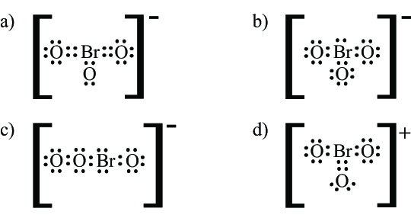

9. According to VSEPR theory, electron groupings in the valence shell of the central atom of a molecule arrange themselves in order that
- the electronegativity difference between atoms is a minimum
- the molecule has the most symmetrical shape
- the electron groupings are as far apart as possible
- the repulsion between them is maximized

10. Which statement about the properties of molecules of CH₂O is correct?
- It is trigonal pyramidal in shape and is a dipole.
- It is trigonal planar in shape and is a dipole.
- It is tetrahedral in shape and non-polar.
- It is linear in shape and non-polar.

11. Which of the following molecules would be pyramidal in shape?
- SO₂(g) c) CF₄(g)
- CS₂(l) d) NI₃(s)

12. Which one of the following compounds will have the highest boiling point?
- CH₃OCH₃(l)
- C₃H₈(l)
- C₃H₅OH(l)
- C₃H₆(l)

13. Which one of the compounds listed below has only London (dispersion) forces between molecules?
- C₄H₉OH(l)
- K₂Cr₂O₇(s)
- C₆H₆(l)
- CH₂F₂(g)

14. Which of the following molecules would be polar?
- CO₂(g)
- CH₃OCH₃(g)
c) CF₄(g)
d) NI₃(s)

15. Which one of the following compounds is nonpolar?
- CCl₄(l)
- CH₃OH(l)
- H₂S(g)
- NH₃(g)

16. Argon is a noble gas that freezes to a solid at −189 °C. What type of bonds will form between atoms of argon in the solid state?
- polar covalent
- covalent
- London dispersion forces
- dipole-dipole

17. Water (H₂O) boils at 100 °C and hydrogen sulfide (H₂S) boils at −61 °C. Which statement explains this difference in boiling point?
- The total number of electrons is greater in H₂S than in H₂O.
- There are stronger dipole-dipole attractions between H₂O molecules.
- There are greater London dispersion forces between H₂O molecules.
- The molar mass of H₂S is greater than the molar mass of H₂O.

18. The molecular shape of a molecule may be described as one of the following:
bent trigonal planar tetrahedral pyramidal
What will be the correct ordering of the numbered examples when arranged to match the order of the listed molecular shapes?

1  CH₂O(l) | 2  PH₃(g) | 3  SiCl₄(l) | 4  OF₂(g)

a) 1, 4, 2, 3 c) 2, 4, 3, 1
b) 4, 2, 1, 3 d) 4, 1, 3, 2

19. Four of the chemicals in the table below can be classified as polar covalent molecules at certain temperature and pressure conditions. Which numbers correspond to these polar covalent molecules?

1. NaCl(s) | 4. CCl₄(l) | 7. K₂SO₄(s)
2. CH₃Br(g) | 5. HF(g) | 8. C₁₃H₂₈(l)
3. PI₃(s) | 6. CO₂(g) | 9. OF₂(g)

- 3, 6, 8, 9
- 2, 3, 5, 9
- 2, 4, 5, 9
- 2, 3, 4, 9

20. The following are formulas for covalent compounds. Each is attracted to molecules like itself by different strengths of intermolecular forces. Reorder the formulas below so they correspond to the expected order of their boiling temperatures, from lowest to highest.

1  H₂O(l) | 2  CH₄(g) | 3  C₄H₁₀(g) | 4  CH₂Cl₂(l)

- 2, 3, 4, 1
- 2, 4, 3, 1
- 1, 3, 4, 2
- 4, 3, 2, 1

Written Response Questions
Answer each question in the space provided. Use complete sentences and diagrams when necessary.

22. The structural formulas for two compounds that can be derived from ethene are shown below. One has a boiling point of 108 °C and the other boils at 47 °C. Which compound has the lower boiling point? Give a reason for your answer.

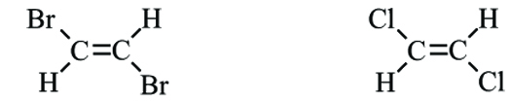

1,2,-dibromoethene 1,2,-dichloroethene

________________________________________________________________________________

_________________________________________________________________________________

_________________________________________________________________________________

_________________________________________________________________________________

23. The structural formulas for three alcohols are shown below.

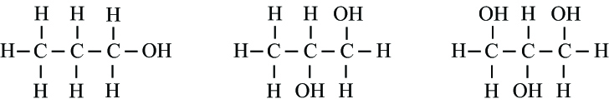

propan-1-ol propane-1,2-diol propane-1,2,3-triol

Compare the intermolecular bonding that is present in these three molecules.

_________________________________________________________________________________

_________________________________________________________________________________

_________________________________________________________________________________

_________________________________________________________________________________

24. Why is a chemical formula for a compound such as ethylene dichloride, C₂H₄Cl₂, not reduced to a simplest whole-number ratio as would be the case for an ionic compound?

_________________________________________________________________________________

_________________________________________________________________________________

_________________________________________________________________________________

Answers to Multiple-Choice Questions

2. b
3. c
4. a
5. c
6. a
8. b
9. c
10. b
11. d
12. c
13. c
14. d
15. a
16. c
17. b
18. d
19. b
20. a

Answers to Written Response Questions

22. When a liquid boils, the heat energy is used to overcome the intermolecular forces of attraction between molecules and the molecules move farther apart. London dispersion forces between molecules increase with an increase in the number of electrons in the molecule. Since chlorine atoms have fewer electrons than bromine atoms, the1,2-dichloroethene has weaker London dispersion forces. Therefore, less energy is needed to spread the molecules apart and
1,2-dichloroethene will boil at the lower temperature of 47 ºC.

23. The most significant difference between the molecules is the number of OH groups on the carbon chain. Molecules having an OH group will form hydrogen bonds to other molecules. The greater the number of OH groups, the greater the amount of hydrogen bonding that can occur. A greater number of OH groups on a molecule also will create slightly stronger dipole–dipole forces between molecules. Similarly the molecule with more OH groups has more electrons and slightly
larger London dispersion forces between molecules. The intermolecular bonding will increase in the order:
propan-1-ol < propane-1,2-diol < propane-1,2,3-ol

24. In an ionic compound, ions are not bonded in pairs as independent units. Each ion is attracted to all of the surrounding neighbouring ions. Therefore, the chemical formula represents the simplest whole-number ratio of ions. In a molecular compound such as C₂H₄Cl₂, all of the atoms are bonded together to form one discrete molecule. The chemical formula must represent all of the atoms present in the molecule.

